Historical Tours
Robben Island- Robben Island Half Day Tour
Price: R1,990 per person
Price: 5-17yrs -R995 per person..
Children 0-4 years- free
Includes hotel pick‑up & drop‑off, ferry ticket, guided island tour
Excludes lunch
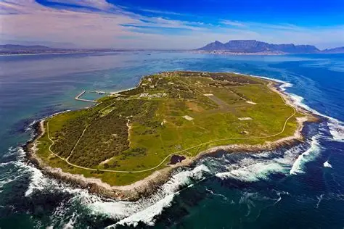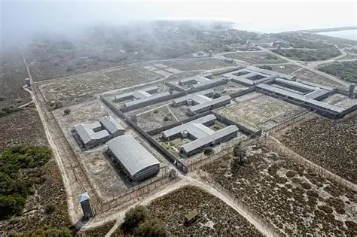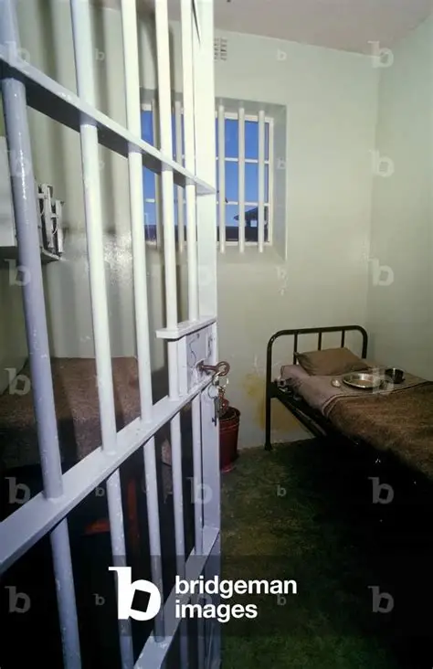
ROBBEN-ISLAND
description: Robben Island is a small island off the coast of Cape Town, South Africa, historically used as a prison for political prisoners, including Nelson Mandela, and now serves as a UNESCO World Heritage Site and museum symbolizing the triumph of the human spirit over oppression. Robben Island, whose name derives from the Dutch word for "seals," spans roughly 5 square miles and lies about 7 kilometres from Cape Town. The island has a long and complex history stretching over 400 years. Other prominent prisoners included Robert Sobukwe, Ahmed Kathrada, and Walter Sisulu. Today, Robben Island is a UNESCO World Heritage Site and home to the Robben Island Museum. Visitors can explore the former prison, historical buildings, and natural landscapes, often guided by former inmates who share firsthand experiences. Robben Island Museum The island's enduring legacy lies in its poignant symbolism of resistance, resilience, and reconciliation, making it a major site of learning and reflection on South African history.
Tour Highlights
- Return ferry ticket
- Guided prison tour
- Nelson Mandela’s cell
- Island bus tour
- Hotel pick‑up & drop‑off
- Professional driver‑guide
What’s Included
- Return ferry ticket
- Guided Robben Island tour
- Hotel pick‑up & drop‑off (Cape Town CBD, Green Point, Sea Point)
- Air‑conditioned vehicle
- Bottled water
Exclusions
- Lunch
- Personal purchases
🕒 Duration-4–5 hours-Morning & afternoon departures available.
Ferry Departures & Schedule
Ferries depart from the Nelson Mandela Gateway at the V&A Waterfront:
09:00 — First departure (best for calm seas)
11:00 — Mid-morning departure
13:00 — Afternoon departure (most popular)
The crossing takes approximately 30 minutes each way. Total tour duration is 3.5-4 hours.

